
Tertiary Infotech Academy Pte Ltd
UEN: 201200696W
LEARNER GUIDE
For
Autodesk Revit Architecture Masterclass
Course Code: C508
Conducted by
Tertiary Infotech Academy Pte Ltd
UEN: 201200696W
Version 1.0

DOCUMENT VERSION CONTROL RECORD
Version Number | Effective Date of Release | Summary of Included Changes | Author
1.0 | 1 October 2026 | First release of the Autodesk Revit Architecture Masterclass learner guide: 12 step-by-step labs with reusable Revit models, environment setup, a skills-consolidation checklist and a glossary. | Dr Alfred Ang

TABLE OF CONTENTS
Introduction 4
Course Learning Outcomes 4
Before You Start — Environment Setup 4
Topic 01 — Design Modeling in Revit 5
Lab 1 — Create a Project and Add Levels 5
Lab 2 — Create a Terrain and Building Pad 6
Lab 3 — Create an In-Place Mass and Apply Materials 8
Lab 4 — Render a Photorealistic View 9
Topic 02 — Part Lists for Modeling in Revit 10
Lab 5 — Create Walls 10
Lab 6 — Place Doors and Windows 12
Lab 7 — Create a Floor and a Roof by Footprint 13
Lab 8 — Create Stairs and Railings 14
Topic 03 — Model Documentation 15
Lab 9 — Add Dimensions to the Model 15
Lab 10 — Create Rooms, an Area Plan and a Color Fill Legend 16
Lab 11 — Create Section, Callout and Dependent Views 18
Topic 04 — Design Specification 19
Lab 12 — Families, Tags, a Schedule and Drawing Sheets 19
Consolidating Your Skills 21
Glossary 21

Introduction
This Learner Guide accompanies the course Autodesk Revit Architecture Masterclass (C508), conducted by Tertiary Infotech Academy Pte Ltd. It provides step-by-step instructions for all 12 hands-on labs, organised by the four course topics.
Use this guide alongside the course slides and the lab folders in the labs/ directory of the course repository. Each lab folder contains this guide's instructions as a README.md and a PDF, together with the Autodesk Revit file(s) used in that lab.

Course Learning Outcomes
- LO1: Produce and visualise 2D/3D technical drawings using Revit
- LO2: Create part lists for modeling using Revit
- LO3: Assist in design prototyping and create design documentation
- LO4: Produce design specification using Revit

Before You Start — Environment Setup
What you need
- Autodesk Revit (a recent release — the labs use the Architecture tools; the free 30-day trial or an education licence from autodesk.com works).
- A Windows PC that meets the Revit system requirements (Revit does not run natively on macOS — use Boot Camp/Parallels or a lab machine).
- The course lab files: download them from the LMS/TMS portal (https://lms-tms.tertiaryinfotech.com) or copy the labs/ folder from the course repository.
- Each lab folder contains the Revit model(s) it uses — e.g. LittleHouse.rvt, ModelCreation.rvt and the door/window/wall tag families (RFA).
Launch and verify Revit
Start Revit from the Windows Start menu. On the Home page you should see Models (New / Open) and Families. Create a test project from the Architectural Template — if the template list is empty, install the Revit content packs or point Revit at the template folder under File Locations in the Options dialog.
Conventions used in every lab
- Ribbon paths are written as Tab ▸ Panel ▸ Tool, e.g. Architecture ▸ Build ▸ Wall.
- Steps assume the metric architectural template unless the lab says otherwise.
- Save your work as <lab-number>-<your-name>.rvt inside the lab folder so the trainer can review it.
- If a tool is greyed out, check the active view type — many tools only work in a plan, elevation or 3D view.
- Press Esc twice to exit any active tool; Ctrl+Z undoes the last action.

Topic 01 — Design Modeling in Revit
BIM & the Revit platform · User interface · Site design & toposurfaces · Massing · Materials · Rendering
Key concepts
- BIM platform — Revit supports design, drawings and schedules for building information modeling — every sheet, view and schedule presents the same virtual building model.
- Parametric change engine — A change made anywhere — model views, sheets, schedules, sections, plans — is coordinated automatically everywhere else.
- Revit user interface — Ribbon, Application Menu, Quick Access Toolbar, Project Browser, Properties palette, Options Bar and View Control Bar.
- Site design — Sketch a toposurface, then add property lines, a building pad, parking and site components; present it in 3D or rendered views.
- Massing studies — Conceptual mass families and in-place masses let you study volumes, zoning and floor-area ratio before detailed modeling.
- Materials & rendering — Materials control graphics, appearance, thermal and physical data; the Render tool produces photorealistic images of the model.

Lab 1 — Create a Project and Add Levels
Learning outcome: produce and visualise 2D/3D technical drawings using Revit (LO1).
Goal: Start a new Revit project from the architectural template, rename the default levels and add new levels that become the vertical datums for the whole building model.
Workflow
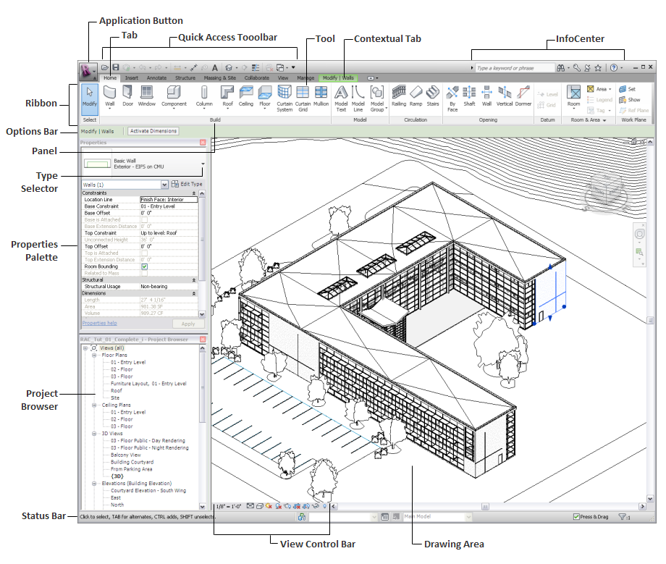
Lab 1 workflow — Create a Project and Add Levels
What you'll build
A Revit project with four named, correctly-elevated levels and their floor-plan views. (Tools: Revit · Architectural Template · Level tool.)
Files for this lab
- LittleHouse.rvt — in labs/lab-01-create-a-project-and-add-levels/
Step-by-step
1. Start Revit and create a new project from the architectural template.
File ▸ New ▸ Project ▸ Architectural Template ▸ OK
2. Open a building elevation so the levels are visible.
Project Browser ▸ Elevations (Building Elevation) ▸ South
3. Rename Level 1 to '01 - Entry Level'; accept renaming the corresponding views.
Double-click the level name ▸ type 01 - Entry Level ▸ Enter ▸ Yes
4. Rename Level 2 to '02 - Upper Level' and set its elevation by clicking the blue elevation value.
Double-click the elevation value ▸ type 3000 ▸ Enter
5. Add a roof level by drawing a new level above the existing ones.
Architecture ▸ Datum ▸ Level ▸ draw left to right above 02
6. Add another level by offsetting from an existing one, then rename it.
Modify | Place Level ▸ Pick Lines ▸ Offset 3000 ▸ click level 02
Test it
The Project Browser lists a floor plan for each new level, and the South elevation shows all four levels with the correct names and elevations. Compare with the completed LittleHouse.rvt model in the lab folder.
Note: This lab's instructions, PDF and Revit file(s) are in labs/lab-01-create-a-project-and-add-levels/.

Lab 2 — Create a Terrain and Building Pad
Learning outcome: produce and visualise 2D/3D technical drawings using Revit (LO1).
Goal: Add a toposurface to the building site by placing points at different elevations, then cut a building pad into the terrain based on the footprint of the foundation walls.
Workflow
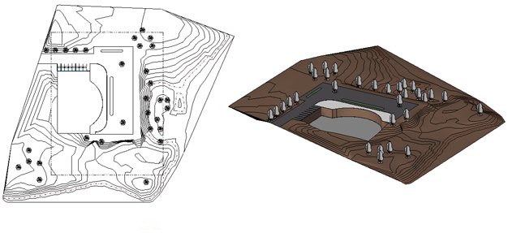
Lab 2 workflow — Create a Terrain and Building Pad
What you'll build
A landscaped site with a graded toposurface, a grass material and a building pad ready for the model. (Tools: Revit · Toposurface · Building Pad · Section Box.)
Files for this lab
- LittleHouse.rvt — in labs/lab-02-create-a-terrain-and-building-pad/
Step-by-step
1. Open the site plan view of the project.
Project Browser ▸ Floor Plans ▸ Site
2. Start the Toposurface tool and place boundary points at elevation 0.
Massing & Site ▸ Model Site ▸ Toposurface ▸ Place Point ▸ Elevation 0
3. Raise the far points: change the elevation on the Options Bar as you place them.
Options Bar ▸ Elevation 900 ▸ click to place the back points
4. Assign a grass material to the surface, then finish it.
Properties ▸ Material ▸ Grass ▸ Finish Surface
5. Sketch a building pad over the foundation footprint on the lower level.
Massing & Site ▸ Model Site ▸ Building Pad ▸ Pick Walls ▸ Finish
6. Frame the result in 3D with a section box to see the pad cutting the terrain.
3D view ▸ Properties ▸ Section Box ✓ ▸ drag the handles
Test it
The 3D view shows the terrain with a grass material, and the building pad cuts a level recess into the toposurface at the foundation walls.
Note: This lab's instructions, PDF and Revit file(s) are in labs/lab-02-create-a-terrain-and-building-pad/.

Lab 3 — Create an In-Place Mass and Apply Materials
Learning outcome: produce and visualise 2D/3D technical drawings using Revit (LO1).
Goal: Model a conceptual building volume as an in-place mass, then use the Materials browser to control how model elements display in shaded and rendered views.
Workflow
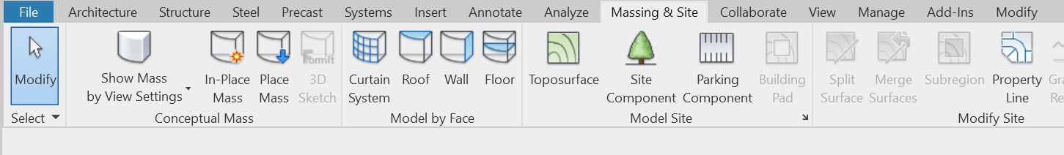
Lab 3 workflow — Create an In-Place Mass and Apply Materials
What you'll build
An in-place conceptual mass with materials applied by category and by face. (Tools: Revit · In-Place Mass · Materials Browser · Paint tool.)
Files for this lab
- ModelCreation.rvt — in labs/lab-03-create-an-in-place-mass-and-apply-materials/
Step-by-step
1. Start an in-place mass and name the new mass family.
Massing & Site ▸ Conceptual Mass ▸ In-Place Mass ▸ name it Tower ▸ OK
2. Draw a closed profile and create a form from it.
Draw ▸ Rectangle ▸ select the profile ▸ Modify ▸ Create Form ▸ Solid Form
3. Finish the mass to return to the project environment.
In-Place Editor ▸ Finish Mass
4. Open the Materials browser and duplicate a material to customise it.
Manage ▸ Settings ▸ Materials ▸ right-click Concrete ▸ Duplicate
5. Set the material's graphics: shading colour, surface pattern and cut pattern.
Material Editor ▸ Graphics ▸ Shading ▸ choose a colour ▸ OK
6. Paint the new material onto one face of the mass.
Modify ▸ Geometry ▸ Paint ▸ pick the material ▸ click a face
Test it
The mass displays the painted material on the selected face in a shaded 3D view, and the duplicated material appears in the project's material library.
Note: This lab's instructions, PDF and Revit file(s) are in labs/lab-03-create-an-in-place-mass-and-apply-materials/.

Lab 4 — Render a Photorealistic View
Learning outcome: produce and visualise 2D/3D technical drawings using Revit (LO1).
Goal: Present the design by producing a photorealistic image of the building model: set the render quality, resolution, lighting and background, then export the image.
Workflow
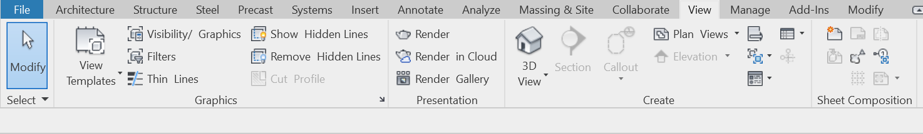
Lab 4 workflow — Render a Photorealistic View
What you'll build
A rendered exterior image of the LittleHouse model, exported to the project and saved as a file. (Tools: Revit · Render dialog · Realistic visual style.)
Files for this lab
- LittleHouse.rvt — in labs/lab-04-render-a-photorealistic-view/
Step-by-step
1. Open LittleHouse.rvt from the lab folder and open the default 3D view.
Quick Access Toolbar ▸ Default 3D View
2. Preview materials in real time with the Realistic visual style.
View Control Bar ▸ Visual Style ▸ Realistic
3. Open the Rendering dialog from the View tab.
View ▸ Graphics ▸ Render
4. Set Quality to Medium and Output to Screen resolution.
Rendering dialog ▸ Quality: Medium ▸ Resolution: Screen
5. Set the lighting scheme and a sky background, then render.
Lighting: Exterior Sun only ▸ Background: Sky ▸ Render
6. Adjust exposure if needed, then save the image into the project and export it.
Adjust Exposure ▸ Save to Project ▸ Export ▸ littlehouse-render.png
Test it
A photorealistic rendering of the house appears under Project Browser ▸ Renderings, and the exported PNG opens outside Revit.
Note: This lab's instructions, PDF and Revit file(s) are in labs/lab-04-render-a-photorealistic-view/.

Topic 02 — Part Lists for Modeling in Revit
Levels & grids · Stacked, basic and curtain walls · Doors & windows · Roofs · Ceilings · Floors & openings · Stairs · Columns
Key concepts
- Levels & grids — Levels are datums for each storey or reference height; grids are annotation elements that organise the design — add columns at grid intersections.
- Wall types — Basic walls, stacked walls (two or more subwalls of different thickness) and curtain walls with grids, panels and mullions.
- Doors & windows — Hosted components that automatically cut their opening; press Spacebar to flip the swing before placement.
- Roofs & ceilings — Create roofs by footprint, extrusion, sloped glazing or from a mass; place ceilings automatically inside walls or by sketch.
- Floors & openings — Sketch floor boundaries as closed loops; cut openings By Face, Vertical, or through the full height with the Shaft tool.
- Stairs & railings — Assemble runs, landings, supports and railings in stair assembly edit mode, in plan or 3D views.

Lab 5 — Create Walls
Learning outcome: create part lists for modeling using Revit (LO2).
Goal: Work on different levels to add the exterior walls, interior partition walls and a corridor to the project, then tidy the joins with the Trim/Extend tool.
Workflow
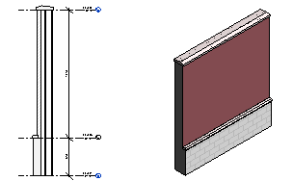
Lab 5 workflow — Create Walls
What you'll build
A building shell with exterior walls, interior walls and a corridor opening on the lower level. (Tools: Revit · Wall: Architectural · Trim/Extend.)
Files for this lab
- ModelCreation.rvt — in labs/lab-05-create-walls/
Step-by-step
1. Open the lower-level floor plan and start the architectural Wall tool.
Architecture ▸ Build ▸ Wall ▸ Wall: Architectural
2. Pick the wall type and set base/top constraints in the Properties palette.
Type Selector ▸ Basic Wall: Generic 200mm ▸ Top Constraint: Up to level 02
3. On the Options Bar set the Location Line and enable Chain, then draw the exterior walls clockwise.
Options Bar ▸ Location Line: Wall Centerline ▸ Chain ✓
4. Add the interior partition walls with a thinner wall type.
Type Selector ▸ Basic Wall: Interior 135mm Partition
5. Create the corridor by trimming the partition walls to form the opening.
Modify ▸ Trim/Extend to Corner ▸ click the two walls to keep
6. Check the shell in 3D and correct any wall join problems.
Default 3D View ▸ inspect ▸ Modify ▸ Wall Joins if needed
Test it
The lower level shows a closed exterior shell with interior partitions and a corridor; walls meet cleanly with no gaps or crossing lines. Compare with ModelCreation.rvt in the lab folder.
Note: This lab's instructions, PDF and Revit file(s) are in labs/lab-05-create-walls/.

Lab 6 — Place Doors and Windows
Learning outcome: create part lists for modeling using Revit (LO2).
Goal: Load door families into the project, then place interior and exterior doors and windows — flipping swing and orientation with the Spacebar and flip controls.
Workflow
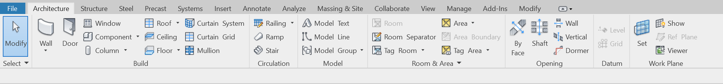
Lab 6 workflow — Place Doors and Windows
What you'll build
A model with doors and windows placed and correctly oriented in the walls, each opening cut automatically. (Tools: Revit · Door tool · Window tool · Load Family.)
Files for this lab
- LittleHouse.rvt — in labs/lab-06-place-doors-and-windows/
Step-by-step
1. Open the entry-level floor plan and start the Door tool.
Architecture ▸ Build ▸ Door
2. Load additional door families from the library.
Modify | Place Door ▸ Mode ▸ Load Family ▸ Doors ▸ choose an entrance door
3. Enable tagging on placement so each door is numbered automatically.
Modify | Place Door ▸ Tag ▸ Tag on Placement
4. Hover over a wall, press Spacebar to flip the swing, then click to place the door.
Spacebar to flip ▸ click to place
5. Place windows on the exterior walls with the Window tool.
Architecture ▸ Build ▸ Window ▸ click the exterior walls
6. Fix any wrongly-placed component with the blue flip-control arrows.
Select the door/window ▸ click the flip arrows
Test it
Every door and window sits in a wall with its opening cut automatically, tags show sequential numbers, and all swings open the intended way.
Note: This lab's instructions, PDF and Revit file(s) are in labs/lab-06-place-doors-and-windows/.

Lab 7 — Create a Floor and a Roof by Footprint
Learning outcome: create part lists for modeling using Revit (LO2).
Goal: Create a mezzanine floor by sketching its boundary, edit the sketch with Align and Trim into a closed loop, then complete the envelope with a footprint roof whose slopes you define.
Workflow
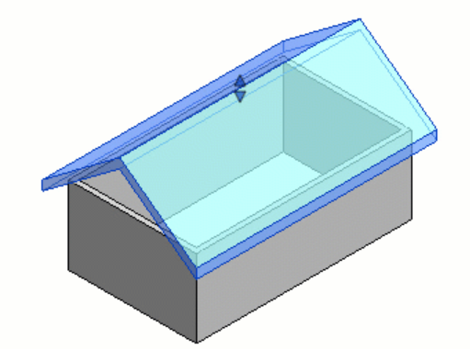
Lab 7 workflow — Create a Floor and a Roof by Footprint
What you'll build
A mezzanine floor in the store-room area and a sloped roof closing the building envelope. (Tools: Revit · Floor: Architectural · Roof by Footprint · Shaft Opening.)
Files for this lab
- ModelCreation.rvt — in labs/lab-07-create-a-floor-and-a-roof-by-footprint/
Step-by-step
1. Open the upper-level plan and start the architectural Floor tool.
Architecture ▸ Build ▸ Floor ▸ Floor: Architectural
2. Pick the bounding walls, then switch to Line to close the open edge.
Modify | Create Floor Boundary ▸ Pick Walls ▸ Draw ▸ Line
3. Use Align and Trim to make the sketch one closed loop, then finish.
Modify ▸ Align / Trim ▸ ✓ Finish Edit Mode
4. Cut a stair opening through the new floor with the Shaft tool.
Architecture ▸ Opening ▸ Shaft ▸ sketch the opening ▸ Finish
5. Create the roof from the building footprint on the roof level.
Architecture ▸ Build ▸ Roof ▸ Roof by Footprint ▸ Pick Walls
6. Set which boundary lines define a slope, then finish and view in 3D.
Select a line ▸ Properties ▸ Defines Roof Slope ✓ ▸ ✓ Finish
Test it
The mezzanine floor appears with a clean shaft opening, and the 3D view shows a sloped roof sitting on the footprint — no warnings about open loops.
Note: This lab's instructions, PDF and Revit file(s) are in labs/lab-07-create-a-floor-and-a-roof-by-footprint/.

Lab 8 — Create Stairs and Railings
Learning outcome: create part lists for modeling using Revit (LO2).
Goal: Complete the interior by adding a staircase from the store floor to the mezzanine, then modify the mezzanine railing and change its type to a pipe railing.
Workflow
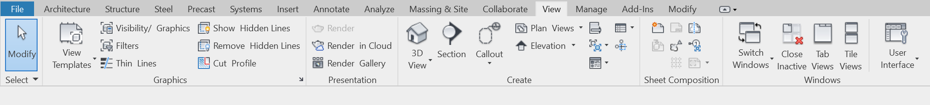
Lab 8 workflow — Create Stairs and Railings
What you'll build
A staircase connecting the store floor to the mezzanine, with a matching pipe railing on the mezzanine edge. (Tools: Revit · Stair tool · Railing tool.)
Files for this lab
- LittleHouse.rvt — in labs/lab-08-create-stairs-and-railings/
Step-by-step
1. Open the lower-level plan and start the Stair tool.
Architecture ▸ Circulation ▸ Stair
2. Set the base and top levels for the run in the Properties palette.
Properties ▸ Base Level: 01 ▸ Top Level: Mezzanine
3. Choose the railing type to generate with the stair.
Modify | Create Stair ▸ Tools ▸ Railing ▸ pick a type
4. Draw the run: click the start point, move up-screen, click the end point.
Components ▸ Run ▸ Straight ▸ click start ▸ click end
5. Finish the stair and inspect it in 3D.
✓ Finish Edit Mode ▸ Default 3D View
6. Select the mezzanine railing and change it to a pipe railing type.
Select railing ▸ Type Selector ▸ Railing: Pipe
Test it
The 3D view shows a complete stair with railings from the store floor to the mezzanine, and the mezzanine edge railing is the pipe type.
Note: This lab's instructions, PDF and Revit file(s) are in labs/lab-08-create-stairs-and-railings/.

Topic 03 — Model Documentation
Dimensions · Rooms · Area plans · Furniture plans · Color fill legends · Dependent views · Object styles · Callout & section views
Key concepts
- Dimensions — Temporary dimensions appear while placing; permanent dimensions (aligned, linear, angular, radial, arc length) document the design and print on sheets.
- Rooms — Rooms are subdivisions bounded by walls, floors, roofs and ceilings; Revit computes perimeter, area and volume, and room separation lines subdivide open space.
- Area plans — Area schemes and boundary lines measure gross/rentable areas per level, created from the Room & Area panel.
- Color fill legends — Color schemes paint rooms or areas in plan views; the legend provides the key and is edited from the Scheme panel.
- Views for a purpose — Duplicate (with detailing / as dependent) to make furniture plans, callouts of wall details and building sections.
- Object styles & visibility — Object Styles set project-wide line weight, colour, pattern and material per category; Visibility/Graphics overrides them per view.

Lab 9 — Add Dimensions to the Model
Learning outcome: assist in design prototyping and create design documentation (LO3).
Goal: Dimension the footprint of the main building: overall widths, then aligned dimension strings that automatically pick up grid intersections and window openings on the exterior walls.
Workflow
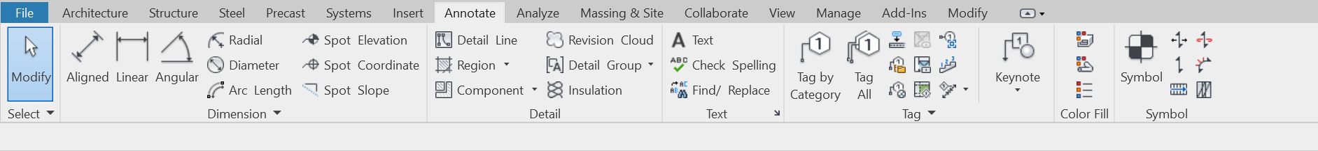
Lab 9 workflow — Add Dimensions to the Model
What you'll build
A dimensioned floor plan documenting the building footprint, grids and openings. (Tools: Revit · Aligned Dimension · Linear Dimension.)
Files for this lab
- LittleHouse.rvt — in labs/lab-09-add-dimensions-to-the-model/
Step-by-step
1. Open the entry-level floor plan of LittleHouse.rvt.
Project Browser ▸ Floor Plans ▸ 01 - Entry Level
2. Start the Aligned dimension tool and set the snap preference.
Annotate ▸ Dimension ▸ Aligned ▸ Options Bar ▸ Prefer: Wall faces
3. Dimension the overall width: click the two outer wall faces, then click to place the line.
Click wall face ▸ click opposite face ▸ click to place
4. Dimension the exterior wall with grid intersections picked up automatically.
Options Bar ▸ Pick: Entire Walls ▸ Options ▸ Intersecting Grids ✓
5. Add the window openings to the same dimension string.
Options ▸ Openings: Centers ✓ ▸ click the exterior wall
6. Place a linear dimension between two points and align it with the Spacebar.
Annotate ▸ Dimension ▸ Linear ▸ pick two points ▸ Spacebar
Test it
The plan shows an overall dimension plus a string that lists every grid intersection and window centre along the exterior wall — values update if a window is moved.
Note: This lab's instructions, PDF and Revit file(s) are in labs/lab-09-add-dimensions-to-the-model/.

Lab 10 — Create Rooms, an Area Plan and a Color Fill Legend
Learning outcome: assist in design prototyping and create design documentation (LO3).
Goal: Subdivide the model into rooms, create an area plan for the level, then colour the plan with a colour scheme and place its legend as the key.
Workflow
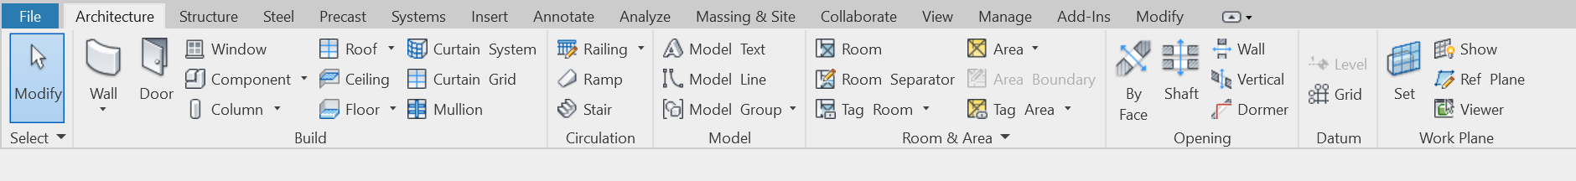
Lab 10 workflow — Create Rooms, an Area Plan and a Color Fill Legend
What you'll build
A room-tagged plan, a gross-area plan and a colour-filled plan with legend. (Tools: Revit · Room tool · Area Plan · Color Fill Legend.)
Files for this lab
- LittleHouse.rvt — in labs/lab-10-create-rooms-an-area-plan-and-a-color-fill-legend/
Step-by-step
1. Place rooms in every enclosed space on the entry level.
Architecture ▸ Room & Area ▸ Room ▸ click inside each space
2. Rename the rooms by editing their tags.
Double-click a room tag ▸ type the name ▸ Enter
3. Create an area plan for the entry level, letting Revit add the boundary lines.
Architecture ▸ Room & Area ▸ Area ▸ Area Plan ▸ Level 01 ▸ Yes
4. Place a colour fill legend beside the plan.
Annotate ▸ Color Fill ▸ Legend ▸ click in the drawing area
5. Choose the space type and colour scheme for the legend.
Choose Space Type: Rooms ▸ Color Scheme: Name ▸ OK
6. Edit the scheme to colour by department or by name.
Select legend ▸ Edit Scheme ▸ pick a scheme ▸ OK
Test it
Every space carries a named room tag, the area plan reports the level's areas, and the plan is colour-filled with a legend that matches the scheme.
Note: This lab's instructions, PDF and Revit file(s) are in labs/lab-10-create-rooms-an-area-plan-and-a-color-fill-legend/.

Lab 11 — Create Section, Callout and Dependent Views
Learning outcome: assist in design prototyping and create design documentation (LO3).
Goal: Create a building section through the model, a callout view of the exterior wall, and a detail callout of the parapet; then duplicate a plan as a dependent view and as a furniture plan.
Workflow
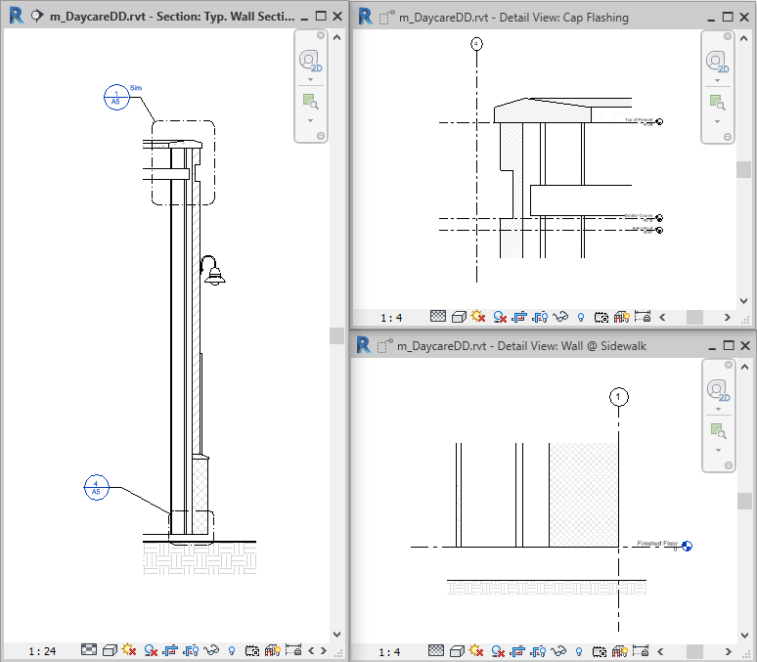
Lab 11 workflow — Create Section, Callout and Dependent Views
What you'll build
A section view, wall-section callout, detail callout and purpose-made duplicate views. (Tools: Revit · Section tool · Callout tool · Duplicate View.)
Files for this lab
- LittleHouse.rvt — in labs/lab-11-create-section-callout-and-dependent-views/
Step-by-step
1. Draw a building section through the model from the entry-level plan.
View ▸ Create ▸ Section ▸ click start ▸ click end
2. Resize the crop region and flip the view direction if needed, then open the section.
Drag the blue controls ▸ double-click the section head
3. Create a wall-section callout of the exterior wall in the section view.
View ▸ Create ▸ Callout ▸ Rectangle ▸ drag around the wall
4. Create a detail callout of the parapet inside the wall section.
View ▸ Create ▸ Callout ▸ Detail ▸ drag around the parapet
5. Duplicate the entry-level plan as a dependent view and crop it to one wing.
Project Browser ▸ right-click plan ▸ Duplicate View ▸ Duplicate as Dependent
6. Duplicate with detailing to make a furniture plan, half-toning the model categories.
Duplicate with Detailing ▸ Visibility/Graphics ▸ Halftone
Test it
The Project Browser shows the section, the two callouts and the dependent/furniture views; each callout head links to its enlarged view.
Note: This lab's instructions, PDF and Revit file(s) are in labs/lab-11-create-section-callout-and-dependent-views/.

Topic 04 — Design Specification
System, loadable & in-place families · Type catalogs · Detail components · Schedules · Drawing sheets · Worksharing · CAD links · Project management
Key concepts
- Three kinds of families — System families (walls, roofs, floors), loadable families (doors, windows, furniture, title blocks — RFA files) and in-place families for one-off elements.
- Type catalogs — Load only the family types you need to keep the project small and the Type Selector short.
- Schedules — Schedule/Quantities lists building components; choose fields, filter, sort, group and format — the schedule is live model data.
- Drawing sheets — A construction document set is composed of sheets; each placed view becomes a viewport with a title block, then print or export to PDF.
- Worksharing — Team members share a central model and work simultaneously in local copies organised by worksets.
- Link & import CAD — Link or import DWG/DXF data, acquire or publish shared coordinates, audit the model and transfer project standards.

Lab 12 — Families, Tags, a Schedule and Drawing Sheets
Learning outcome: produce design specification using Revit (LO4).
Goal: Load the door, window and wall tag families supplied in the lab folder, tag the model, build a door schedule, then compose a titled drawing sheet with plan, section and schedule — the deliverable construction document.
Workflow
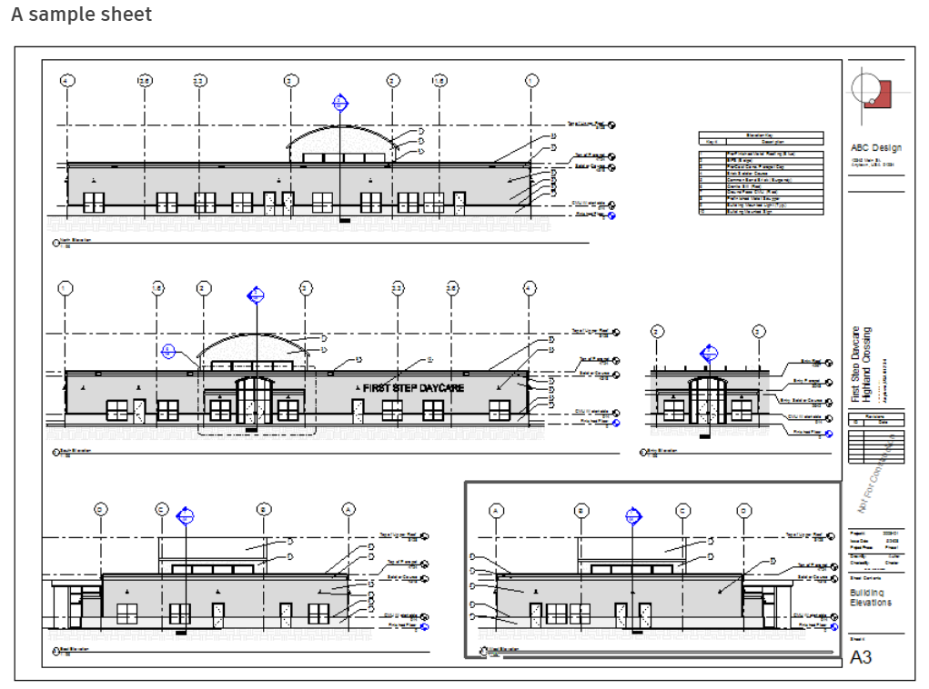
Lab 12 workflow — Families, Tags, a Schedule and Drawing Sheets
What you'll build
A construction-document sheet with title block carrying the plan, a section, tags and a live door schedule. (Tools: Revit · Load Family · Tag by Category · Schedule/Quantities · Sheet.)
Files for this lab
- LittleHouse.rvt — in labs/lab-12-families-tags-a-schedule-and-drawing-sheets/
- Door Tag FR.rfa — in labs/lab-12-families-tags-a-schedule-and-drawing-sheets/
- Window Tag.rfa — in labs/lab-12-families-tags-a-schedule-and-drawing-sheets/
- Wall tag.rfa — in labs/lab-12-families-tags-a-schedule-and-drawing-sheets/
Step-by-step
1. Load the three tag families supplied in this lab's folder.
Insert ▸ Load from Library ▸ Load Family ▸ select the 3 RFA files
2. Tag the doors, windows and walls in the entry-level plan.
Annotate ▸ Tag ▸ Tag by Category ▸ click each element
3. Create a door schedule and choose its fields.
View ▸ Create ▸ Schedules ▸ Schedule/Quantities ▸ Doors ▸ add Mark, Type, Width, Height
4. Sort the schedule by Mark and format the headers.
Schedule Properties ▸ Sorting/Grouping ▸ Mark ▸ Formatting
5. Create a sheet from a title block and rename it.
View ▸ Sheet Composition ▸ Sheet ▸ A1 metric ▸ rename A101 - Plans
6. Drag the plan, the section and the schedule onto the sheet and arrange the viewports.
Drag views from the Project Browser onto the sheet
7. Print or export the sheet to PDF as the issued document.
File ▸ Print ▸ PDF driver ▸ Selected views/sheets ▸ OK
Test it
Sheet A101 shows the plan, section and door schedule inside the title block; the schedule updates live when a door type changes, and the exported PDF matches the sheet.
Note: This lab's instructions, PDF and Revit file(s) are in labs/lab-12-families-tags-a-schedule-and-drawing-sheets/.

Consolidating Your Skills
- First pass: complete every lab in Revit, comparing your result with the Test-it check.
- Second pass: redo the labs from memory until the ribbon paths and workflows are automatic.
- Review the Key Concepts of each topic to consolidate the theory behind each lab.
- Practise end-to-end: model, document and specify a small building in Revit, drawing on the labs.
- Sharpen your readiness with the practice exams at https://exams.tertiaryinfotech.com.

Glossary
- BIM — Building Information Modeling — a single coordinated virtual building model that drives every drawing, view and schedule.
- Parametric change engine — Revit's coordination mechanism: a change made anywhere updates every view, sheet and schedule.
- Level — A horizontal datum plane for a storey or reference height (e.g. sill level); floor plans attach to levels.
- Grid — An annotation datum used to organise the design; columns can be placed at grid intersections.
- Toposurface — A topographical surface defined by points or imported data, used for site modeling.
- Building pad — A flat pad sketched on a toposurface that cuts the terrain to level ground for the building.
- Mass — A conceptual volume (family-based or in-place) used for early design studies; can generate walls, floors and roofs.
- Family — A group of elements with a common set of properties: system families, loadable families (RFA) and in-place families.
- Type / Instance — A type defines shared parameters for all its elements; an instance carries the parameters of one placed element.
- Curtain wall — A wall type made of panels, curtain grids and mullions.
- Callout view — An enlarged view of part of a parent view, linked by the callout tag.
- Section view — A view that cuts through the model along a drawn section line.
- Dependent view — A duplicate view that stays synchronised with its primary view — used to split a large plan across sheets.
- Room — A subdivision of space bounded by room-bounding elements; Revit computes its perimeter, area and volume.
- Schedule — A live tabular view of model data (e.g. a door schedule) created with Schedule/Quantities.
- Sheet — A drawing sheet with a title block; placed views become viewports and form the construction document set.
- Workset — A subdivision of a workshared project that lets team members edit a central model simultaneously.
- RVT / RFA / RTE — Revit file types: project, loadable family and project template respectively.

